SEO Navigator: From Audit to Action
Comprehensive SEO Audit Report
Zoho Corporation Pvt. Ltd.


TABLE OF CONTENTS
- Company Profile
- Initial SEO Audit
- Technical SEO Analysis
- On-Page SEO Analysis
- Off-Page SEO Analysis
- SWOT Analysis
- Keyword Research
- Competitor Analysis
- Content Strategy
- SEO Strategy & Recommendations
- Conclusion
- References

PROJECT OBJECTIVE

To conduct a comprehensive SEO audit of Zoho Corporation's website by evaluating technical SEO, on-page SEO, off-page SEO, keyword opportunities, and website performance. The project aims to identify optimization opportunities that improve search visibility, user experience, and organic traffic.
INTRODUCTION
In today's competitive digital environment, an effective online presence is essential for business growth. This project evaluates Zoho Corporation's website through a comprehensive SEO audit, analyzing its technical SEO, on-page SEO, off-page SEO, keyword strategy, and overall website performance. The audit identifies opportunities to improve search visibility, user experience, and organic traffic.
Particulars | Details
Company Name
  Zoho Corporation Pvt. Ltd.
Industry | Software as a Service (SaaS)
Founded | 1996
Headquarters | Chennai, Tamil Nadu, India
Founders | Sridhar Vembu & Tony Thomas
Products
  CRM, Books, Mail, Projects, People, Desk, Creator and more
Website
  www.zoho.com

OVERVIEW
Zoho Corporation Pvt. Ltd. is a leading provider of cloud-based business software that helps organizations streamline their operations through a single integrated platform. Its solutions enable businesses to improve productivity, collaboration, and customer management while supporting digital transformation with secure and user-friendly applications and manage everyday processes effectively, making it a trusted technology partner for businesses worldwide.
MISSION
To provide powerful, affordable, and privacy-focused cloud software that enables businesses of all sizes to improve productivity and achieve sustainable growth.

VISION
To empower businesses worldwide with innovative technology solutions that simplify operations and drive digital transformation

Why I Selected ZOHO
- One of India's leading SaaS companies.
- Strong global digital presence.
- Professional and user-friendly website.
- Excellent SEO and digital marketing practices.
- Ideal for website audit and landing page analysis.

2. INITIAL SEO AUDIT
Website Audit Summary
The Zoho website was evaluated based on website design, user experience (UX), performance, accessibility, SEO, and overall functionality. The audit included both manual observation and Google PageSpeed Insights analysis for mobile and desktop versions. Overall, the website demonstrates a strong digital presence with an intuitive interface, excellent accessibility, and well-implemented SEO practices. However, performance optimization can further enhance the user experience, especially on mobile devices.
1. Website Design
Zoho's website features a clean, modern, and professional design that reflects the company's brand identity. The homepage effectively showcases important products through the Featured Apps section and highlights the Zia Agent platform with a visually engaging hero banner. The consistent color scheme, typography, and high-quality visuals contribute to a positive first impression and improve overall usability.
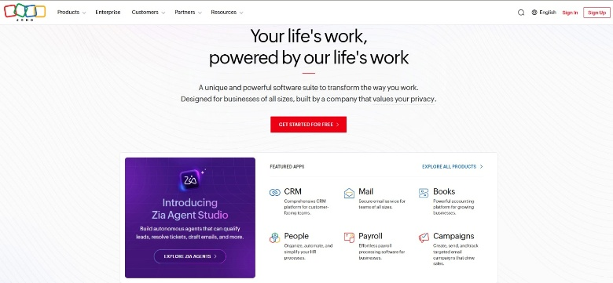
Figure: Zoho Homepage showing Featured Apps, Zia Agent, and the "Get Started for Free" call-to-action.

User Experience (UX)
The website provides an intuitive and user-friendly experience. The navigation menu is well organized, allowing users to easily access products, services, pricing, and support resources. Information is logically structured, making it simple for visitors to find relevant content. The "Get Started for Free" call-to-action button is prominently displayed, encouraging visitors to explore Zoho's services and increasing the likelihood of lead generation.
Performance Analysis
The website was tested using Google PageSpeed Insights.
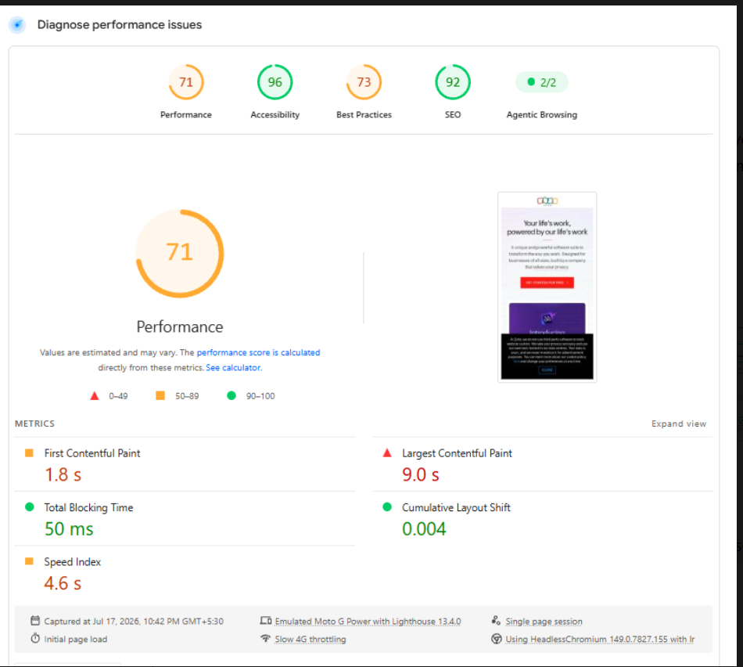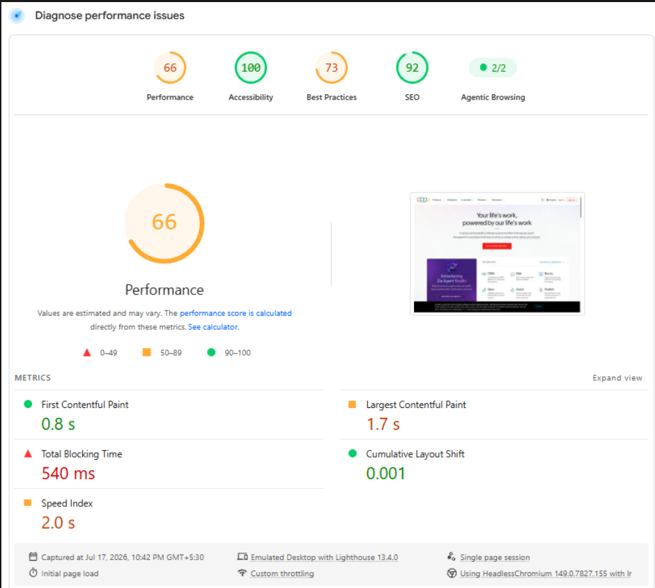
Figure: Google PageSpeed Insights – Mobile Performance Analysis Figure: Google PageSpeed Insights – Desktop Performance Analysis
Mobile Performance | Desktop Performance
  Metric | Score
  Performance | 71
  Accessibility | 96
  Best Practices | 73
  SEO | 92
  Metric | Score
  Performance | 66
  Accessibility | 100
  Best Practices | 73
  SEO | 92
The PageSpeed Insights audit shows that Zoho achieves excellent scores in Accessibility and SEO, demonstrating compliance with usability and search engine optimization best practices. While the overall performance score is moderate, the website provides a stable browsing experience. The Desktop Core Web Vitals assessment passed successfully, whereas the Mobile Core Web Vitals assessment indicates scope for further performance optimization, particularly in page loading speed and responsiveness.
SEO Analysis
The website follows several SEO best practices that contribute to its strong search engine performance. It uses optimized page titles, relevant meta descriptions, proper heading hierarchy, and SEO-friendly URLs. With an SEO score of 92/100, the website is well positioned for search engine visibility and organic traffic.

3.TECHNICAL SEO STATUS
SEO Factor | Status | Observation
HTTPS Security | ✅ Implemented | Website uses a secure HTTPS protocol to protect user data and improve trust.
Mobile Responsiveness | ✅ Good | The website adapts well across desktop, tablet, and mobile devices.
XML Sitemap | ✅ Available | Helps search engines efficiently discover and index website pages.
Robots.txt | ✅ Available | Guides search engine crawlers and prevent indexing of unnecessary pages.
Core Web Vitals | ⚠️ Moderate | Desktop Core Web Vitals passed successfully, while mobile performance has room for improvement.
Page Speed | ⚠️ Moderate | Good loading speed overall, but image optimization and JavaScript improvements are recommended.
Crawlability | ✅ Good | Search engines can effectively crawl and index the website.
Website Security | ✅ Secure | SSL certificate is implemented, ensuring secure browsing.

Technical SEO Issues Identified
Based on the Lighthouse audit, the following issues were observed:
- Large images increase page loading time.
- Render-blocking resources delay page rendering.
- JavaScript execution time is relatively high.
- Unused CSS and JavaScript increase page size.
- Browser console errors and third-party scripts slightly affect performance.
- Mobile Core Web Vitals require further optimization.
Best Practices to Improve Site Speed
- Optimize and compress images using next-generation formats such as WebP.
- Remove unused CSS and JavaScript files.
- Minimize render-blocking resources.
- Enable browser caching and content compression.
- Reduce third-party scripts and optimize server response time.

4. On-Page SEO Analysis
Element | Observation | Status
Title Tag | Descriptive and keyword relevant | ✅
Meta Description | Present and informative | ✅
URL Structure | Clean and SEO-friendly | ✅
Heading Structure | Proper H1, H2 and H3 hierarchy | ✅
Keyword Usage | Relevant keywords naturally included | ✅
Internal Linking | Strong internal navigation | ✅
External Links | Properly linked to product resources | ✅
Image Optimization | Most images include descriptive alt text | ✅

On-Page SEO Observations
- The homepage uses a clear and descriptive page title.
- Meta descriptions accurately summarize the page content.
- Heading hierarchy improves readability and SEO.
- Internal links help users navigate products and services efficiently.
- Images are generally optimized with meaningful alternative text.
- Call-to-action buttons are prominently displayed to encourage user engagement.

5. Off-Page SEO Analysis
Factor | Observation
Domain Authority | Strong domain authority with high online credibility
Brand Presence | Recognized globally as a leading SaaS provider
Social Media | Active on LinkedIn, YouTube, Facebook, X and other platforms
Backlink Profile | Strong backlink profile from reputable websites
Brand Reputation | High trust and positive online reputation

Off-Page SEO Observations
- Zoho has established a strong online presence through quality backlinks.
- Active social media engagement improves brand visibility and referral traffic.
- Content marketing through blogs, webinars, and knowledge resources supports organic growth.
- Strong brand recognition contributes to higher search engine trust and authority.

6. SWOT Analysis
Strengths | Weaknesses
Strong SEO implementation and website optimization | Moderate mobile performance
Excellent accessibility and usability | Heavy JavaScript execution
Responsive website design | Render-blocking resources
Secure HTTPS implementation | Large images affect loading speed

Opportunities | Threats
Improve Core Web Vitals | Strong competition from Salesforce, Microsoft, HubSpot, etc.
Optimize images and scripts | Frequent Google algorithm updates
Target more long-tail keywords | Increasing competition in the SaaS industry
Expand AI-focused content marketing | Higher user expectations for website speed

Final Audit Summary
The SEO audit of Zoho Corporation indicates that the website follows strong SEO best practices with excellent accessibility, secure website architecture, and an intuitive user experience. The website is well optimized for search engines through effective metadata, structured headings, and quality internal linking. Technical analysis identified opportunities to improve mobile performance, optimize JavaScript execution, reduce render-blocking resources, and enhance Core Web Vitals. Overall, Zoho maintains a strong digital presence and provides an excellent foundation for achieving sustainable organic search growth.

Strengths
- Modern and professional website design.
- Excellent Accessibility score (96–100).
- Strong SEO implementation (92).
- User-friendly navigation and logical content structure.
- Clear and effective "Get Started for Free" call-to-action.
- Responsive design across different devices.
SEO Recommendations
- Improve website performance on both mobile and desktop.
- Optimize images to reduce loading time.
- Reduce unused CSS and JavaScript.
- Minimize render-blocking resources.
- Address browser console errors and optimize third-party scripts.
Conclusion
The SEO audit concludes that Zoho Corporation has a strong and well-optimized website with excellent accessibility, effective on-page SEO practices, and a secure technical foundation. The website provides a user-friendly experience and demonstrates strong search engine optimization through well-structured metadata, responsive design, and quality internal linking. While improvements in mobile performance, image optimization, and JavaScript efficiency can further enhance search visibility and user experience, Zoho has a solid foundation for sustainable organic growth and improved search engine rankings.

7. KEYWORD RESEARCH
Product 1: Zoho CRM
No. | Keyword | Search Intent
1 | Zoho CRM | Navigational
2 | CRM software | Transactional
3 | Best CRM software | Transactional
4 | Customer relationship management software | Informational
5 | CRM for small business | Transactional
6 | Sales automation software | Transactional
7 | Cloud CRM | Informational
8 | Free CRM software | Transactional
9 | CRM features | Informational
10 | Zoho CRM pricing | Transactional

Product 2: Zoho Books
No. | Keyword | Search Intent
1 | Zoho Books | Navigational
2 | Accounting software | Transactional
3 | GST billing software | Transactional
4 | Online accounting software | Informational
5 | Bookkeeping software | Informational
6 | Invoice software | Transactional
7 | Small business accounting | Informational
8 | Zoho Books pricing | Transactional
9 | Cloud accounting software | Informational
10 | Best accounting software | Transactional

Conclusion
The keyword research identified 20 relevant keywords across Zoho CRM and Zoho Books, covering informational, navigational, and transactional search intent. This balanced keyword strategy enables Zoho to attract users at different stages of the customer journey, from information gathering to product evaluation and purchase decisions. These keywords provide a strong foundation for improving search engine visibility and driving qualified organic traffic.

8. COMPETITOR ANALYSIS
Introduction
Zoho operates in the highly competitive Software as a Service (SaaS) market, where several global companies provide similar business applications. Competitor analysis helps identify how Zoho compares with leading SaaS providers in terms of product offerings, SEO strategies, keyword targeting, content marketing, and overall online visibility. This analysis highlights opportunities for Zoho to strengthen its search engine rankings and digital presence.
Major Competitors
Zoho Product | Major Competitors
Zoho CRM | Salesforce, HubSpot, Microsoft Dynamics 365
Zoho Books | QuickBooks, Xero, FreshBooks

Competitor Comparison
Factor | Zoho | Salesforce | HubSpot | QuickBooks
SEO Score | Excellent | Excellent | Excellent | Excellent
Blog Content | Extensive | Extensive | Very Extensive | Extensive
Product Pages | Well Optimized | Well Optimized | Well Optimized | Well Optimized
Free Trial | Yes | Yes | Yes | Yes
Pricing Transparency | High | Moderate | High | High
Mobile-Friendly Website | Yes | Yes | Yes | Yes

Competitor Keyword Analysis
Zoho Product | Competitors | Common Target Keywords
Zoho CRM | Salesforce, HubSpot, Microsoft Dynamics 365 | CRM software, Sales automation, Customer relationship management, Free CRM, Cloud CRM
Zoho Books | QuickBooks, Xero, FreshBooks | Accounting software, Bookkeeping software, GST billing software, Invoice software, Online accounting software

Competitor SEO Strategy
Zoho CRM Competitors
- Focus on high-volume commercial keywords such as CRM software and Sales automation software.
- Publish blogs, case studies, customer success stories, and comparison pages to increase organic traffic.
- Optimize pricing pages, feature pages, and free trial landing pages for transactional searches.
Zoho Books Competitors
- Target accounting, invoicing, bookkeeping, and GST-related keywords.
- Publish educational blogs, financial guides, and tax-related resources.
- Optimize product pages and comparison articles to improve search visibility and conversion rates.
Competitor Analysis Insights
- Competitors invest heavily in educational content and SEO-driven blogs.
- Product comparison pages help capture high-intent users.
- Free trials and demo pages improve lead generation.
- Long-tail keywords increase visibility for niche customer searches.
- Strong backlink profiles contribute to higher domain authority and search rankings.
Conclusion
The competitor analysis shows that Zoho competes effectively with leading SaaS companies such as Salesforce, HubSpot, QuickBooks, Xero, and FreshBooks. While Zoho demonstrates strong SEO practices and a comprehensive product portfolio, competitors leverage extensive content marketing, targeted keyword strategies, and optimized landing pages to strengthen their organic search visibility. By expanding high-quality content, targeting additional long-tail keywords, and enhancing technical SEO, Zoho can further improve its competitive position in search engine ranking
9. CONTENT STRATEGY
Introduction
A well-planned content strategy plays a vital role in improving search engine rankings, increasing organic traffic, and engaging potential customers. Based on the keyword research and competitor analysis, Zoho can strengthen its digital presence by publishing valuable, keyword-focused content that addresses user needs at different stages of the customer journey.
Content Objectives
The content strategy aims to:
- Improve organic search visibility.
- Increase website traffic through targeted keywords.
- Educate potential customers about Zoho products.
- Generate qualified leads and product sign-ups.
- Build brand authority in the SaaS industry.
Target Audience
Audience | Content Focus
Small Business Owners | CRM, Accounting, Business Automation
Startups | Affordable cloud software solutions
Sales Teams | CRM features, sales automation, lead management
Finance Professionals | Accounting, invoicing, GST compliance
IT Managers | Cloud applications, integrations, security
Entrepreneurs | Productivity tools and business growth strategies

Recommended Content Types
Content Type | Purpose
Blog Articles | Improve keyword rankings and educate users
Product Tutorials | Help users understand product features
Case Studies | Build credibility through customer success stories
Comparison Articles | Compare Zoho products with competitors
Videos & Webinars | Increase user engagement and product awareness
Infographics | Present complex information in a simple visual format
FAQs | Address common customer questions and improve SEO

Content Calendar
Content Type | Frequency | Target Keywords
Blog Posts | Weekly | CRM software, Accounting software
Product Tutorials | Bi-weekly | Zoho CRM, Zoho Books
Customer Success Stories | Monthly | CRM solutions, Business software
Webinars | Monthly | Sales automation, Cloud software
Comparison Articles | Monthly | Best CRM software, Best accounting software
SEO Updates | Quarterly | Long-tail keywords, Industry trends

Content Optimization Strategy
- Naturally incorporate primary and secondary keywords into titles, headings, and body content.
- Write compelling meta titles and meta descriptions.
- Optimize images with descriptive alt text.
- Add internal links between related pages and blog posts.
- Use structured headings (H1, H2, and H3) to improve readability.
- Regularly update existing content to maintain relevance and search rankings.
Expected Outcomes
Objective | Expected Benefit
Higher Keyword Rankings | Improved visibility on search engines
Increased Organic Traffic | More qualified website visitors
Better User Engagement | Longer session duration and lower bounce rate
Lead Generation | More free trial registrations and demo requests
Brand Authority | Stronger online reputation and customer trust

Conclusion
An effective content strategy enables Zoho to improve search engine visibility while delivering valuable information to its target audience. By consistently publishing high-quality, keyword-focused content and regularly updating existing pages, Zoho can strengthen its organic search performance, enhance customer engagement, and generate sustainable business growth.

10. SEO STRATEGY & RECOMMENDATIONS
Introduction
Based on the SEO audit, keyword research, competitor analysis, and content strategy, the following recommendations are proposed to strengthen Zoho's search engine visibility, improve user experience, and increase organic traffic. These strategies focus on technical SEO, on-page optimization, off-page SEO, content marketing, and website performance.
Technical SEO Recommendations
Recommendation | Expected Benefit
Optimize and compress images using modern formats (WebP/AVIF) | Improve page loading speed and Core Web Vitals
Reduce unused JavaScript and CSS | Faster page rendering and improved performance
Minimize render-blocking resources | Improve First Contentful Paint (FCP) and Largest Contentful Paint (LCP)
Enable browser caching and GZIP/Brotli compression | Reduce page load time
Regularly monitor Core Web Vitals | Maintain optimal website performance
Perform periodic technical SEO audits | Detect and resolve technical issues early

On-Page SEO Recommendations
Recommendation | Expected Benefit
Optimize page titles and meta descriptions | Improve click-through rate (CTR)
Include primary keywords in headings (H1, H2, H3) | Better keyword relevance
Enhance internal linking between related pages | Improve navigation and crawlability
Optimize image alt text | Improve accessibility and image SEO
Update outdated content regularly | Maintain content freshness and rankings

Off-Page SEO Recommendations
Recommendation | Expected Benefit
Acquire backlinks from reputable websites | Increase domain authority
Publish guest articles on industry blogs | Expand reach and referral traffic
Strengthen social media engagement | Improve brand awareness
Encourage customer reviews and testimonials | Build trust and credibility
Collaborate with industry influencers and partners | Increase brand visibility
Content Marketing Recommendations
- Publish keyword-focused blog articles on a regular basis.
- Create detailed product tutorials and how-to guides.
- Develop customer success stories and case studies.
- Produce videos, webinars, and product demonstrations.
- Update older content with new information and target keywords.
- Create comparison pages highlighting Zoho's advantages over competitors.
Performance Optimization Recommendations
Issue Identified | Recommended Action
Moderate mobile performance | Optimize mobile page speed and responsiveness
Large image files | Compress images and use next-generation formats
Heavy JavaScript execution | Minify and defer JavaScript files
Render-blocking resources | Load CSS and JavaScript asynchronously
Third-party scripts | Reduce unnecessary external scripts and monitor their impact

Expected Business Impact
Strategy | Expected Outcome
Technical SEO Improvements | Better Core Web Vitals and faster website performance
On-Page SEO Optimization | Higher keyword rankings and improved CTR
Off-Page SEO Activities | Increased domain authority and referral traffic
Content Marketing | More organic visitors and stronger customer engagement
Continuous SEO Monitoring | Sustainable long-term growth in search visibility

Conclusion
Implementing these SEO strategies and recommendations will help Zoho enhance its online visibility, improve website performance, and strengthen its competitive position in the SaaS industry. A balanced approach combining technical optimization, high-quality content, strategic keyword targeting, and authoritative backlink building will contribute to sustainable organic traffic growth, improved user experience, and increased lead generation.

11. CONCLUSION

This project successfully conducted a comprehensive SEO audit of Zoho Corporation's website by evaluating its technical SEO, on-page SEO, off-page SEO, keyword strategy, competitor landscape, content strategy, and overall website performance. The findings indicate that Zoho has established a strong digital presence supported by excellent accessibility, well-structured website architecture, secure HTTPS implementation, and effective SEO practices. While the website performs well in search engine optimization and user experience, there are opportunities to further improve mobile performance, optimize images, reduce JavaScript execution, and enhance Core Web Vitals.
The keyword research and competitor analysis highlighted valuable opportunities to strengthen Zoho's organic search visibility through targeted keywords, high-quality content, and strategic SEO initiatives. By implementing the recommended technical improvements, content marketing strategies, and continuous SEO monitoring, Zoho can further enhance its search engine rankings, attract qualified organic traffic, improve user engagement, and maintain its competitive advantage in the global SaaS industry.
Overall, this SEO audit demonstrates that Zoho has a strong foundation for sustainable digital growth and can continue to improve its online visibility through continuous optimization and best SEO practices.

12. REFERENCES
- Zoho Corporation. (2026). Zoho Official Website. https://www.zoho.com
- Google. (2026). PageSpeed Insights. https://pagespeed.web.dev
- Google. (2026). Lighthouse Documentation. https://developer.chrome.com/docs/lighthouse
- Google. (2026). Google Search Central Documentation. https://developers.google.com/search
- W3C. (2026). Markup Validation Service. https://validator.w3.org
- Ahrefs. (2026). Free Backlink Checker. https://ahrefs.com/backlink-checker

